# Lab 13. Using the DAC: Waveforms on the Arduino

1. Set the Arduino Due to 12-bit accuracy for the DAC using analogWriteResolution. This will give you a range from 0 to 4095. (212 = 4096)  
     
   analogWrite(DAC0, 0);  
   analogWrite(DAC0, 4095);
2. Write a function to create a sawtooth wave with a frequency of 440Hz. Set the values 32 times per wave. This means that you will calculate the delay between times to call analogWrite in microseconds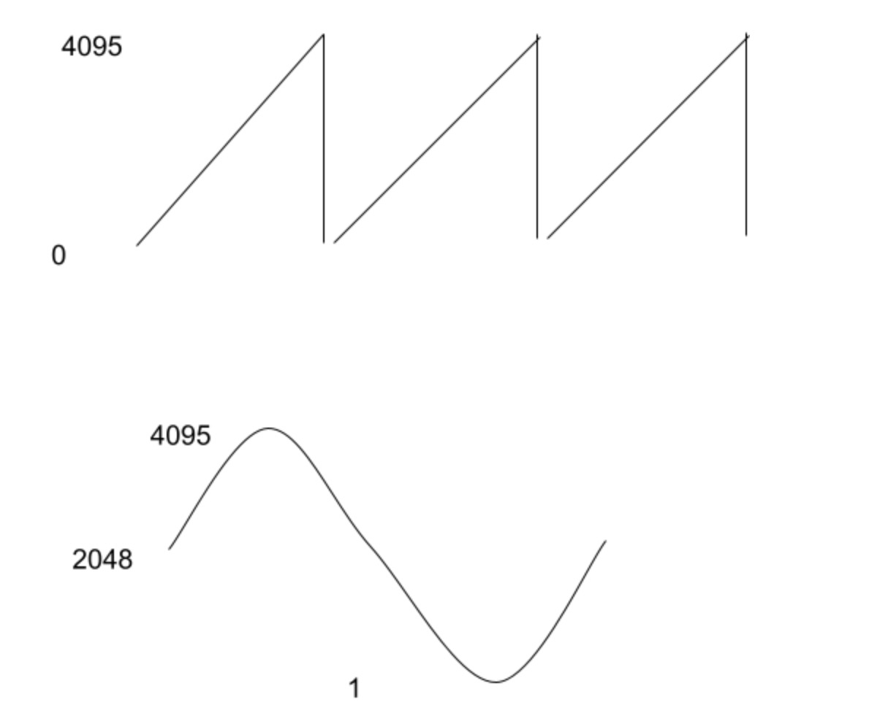
3. Call the sawtooth function from loop.
4. Test the oscilloscope. Connect the leads to the test port on the right of the oscilloscope and make sure you see a square wave.
5. View the sawtooth function on the oscilloscope and verify the period ____________.
6. Write a function to create a sine wave of 440Hz.   
   Define zero as halfway between this range (2048 or 2047). Write a function that creates a sine wave: f(t) = z + asin(t) where for example, a = 2047 and z = 2048 to create the above.
7. You will need to set the DAC at multiple points in the sin wave. Try for 32 at first. That will require selecting the correct delayMicroseconds to create a sine wave of the right frequency.
8. Try to sample only 5 times for the sine wave. What happens to the wave on the oscilloscope?
9. Try to create a higher accuracy wave by using 1000 samples. Calculate the delayMicroseconds you would need in order to do this many samples.____________  
   Given that delayMicroseconds only takes whole numbers, what is the closest integer delay you could use? ____________  
   T = 1/f  
   delay = T / samples  
   What frequency would that delay create, assuming none of the rest of the code takes any time?
10. Now try to create a wave that is 100Khz, T = 10uSec. This is much harder because this is pretty fast with respect to the speed of the computer. Instead of calculating sine, precalculate the waveform as integers and write code to output the wave directly. Measure the waveform your code puts out on the oscilloscope T=_____________.

**Submissions**

1. Give the paper sheet back to your TA with all blanks filled.
2. Submit photos of your waves in oscilloscope.
3. Save and submit the code.